Newsletter of the Auckland Branch of the New Zealand Geographical Society. No. 65 June 2022

Geography Auckland

Kia ora tatou …

The Auckland branch of NZGS promotes the activities of geographers and the development of the discipline in the Auckland region. It has proven an effective platform for hosting and sponsoring public seminars and workshops, and talks by prominent local and international geographers; running competitions for schools; providing opportunities for young geographers to attend conferences; and for bringing geographers together to discuss issues of public and disciplinary concern. One initiative is to seek better links with professional geographers beyond the university and schools.

The Auckland activities include monthly Geography Dialogues with Wine. The Branch invites any members with ideas for activities to bring them forward for discussion and development. It also encourages new members to join. Membership of the New Zealand Geographical Society includes branch membership.

This year’s Awardees for Excellence in First Year Geography appears on page 4

The June Dialogues will be presented by Tom Baker and others: “Innovatory urban governance: A research agenda” – see Page 2

The Canterbury Branch will be hosting the biennial New Zealand Geographical Society Conference at University of Canterbury both in-person and online: 22 – 25 November

The NZ Geographical Society’s newsletter can be found on http://www.nzgs.co.nz

Past copies of Geography Auckland’s newsletter can also be found in the (Branches) Auckland Branch section of http://www.nzgs.co.nz

Auckland Branch Executive

Executive Office Holders

President Graeme Campbell

Vice Presidents June Logie, Mary Flaws

Chair Karen Fisher
Secretary June Logie
Treasurer Tom Baker

BoGT Rep Mary Robinson

Committee Members

Nick Lewis
Richard Le Heron Daniel Exeter
Ward Friesen Lyndsay Blue
Erena Le Heron. Lucy Baragwanath
Regan Solomon JC Gaillard
Emma Sharp Postgrad reps
David Hayward
What’s on?

MONTHLY GEOGRAPHY
DIALOGUES WITH WINE

These meetings give a chance for Geographers to talk informally about their research.

The Auckland Branch invites you to attend the next meeting

Tuesday, 21st June 2022
University of Auckland
Ontology Lab, Level 5, Science Centre, 23 Symonds Street

The Speaker will be Tom Baker

(If you wish to attend via Zoom, a link will be sent to you)

___________________________
Celebrate Geography,
Get excited
Karen Fisher (k.fisher@auckland.ac.nz)
June Logie: june.logie@me.com (secretary)

News for teachers:
Geography Scholarship Lectures:
Theme: Urban Growth:
1 June: What is urban growth? Tom Baker;
29 June: Urban Growth and inequality – Larry Murphy;
17 August: Sustainable Urban Growth? Mel Wall

For your diary:
Monthly Geography Dialogues with Wine 21 June, 5 July, 16 August, 20 September, 18 October, 1 November, 22 November
Newsletter of the Auckland Branch of the New Zealand Geographical Society. No. 65 June 2022

Geography Auckland

Auckland Dialogues
Tuesday 21 June
Building 302, Room 551 Ontology Lab – 4.00pm to 5.30pm
Innovatory urban governance: A research agenda
Tom Baker
As ‘governance innovation’ is embraced as an imperative to address urban policy challenges, many cities are adopting novel governance arrangements, institutions, and mechanisms. Yet, innovatory urban governance—a distinctive set of urban governance practices and heterogeneous political project—is not well understood within critical urban scholarship. Stemming from a collaborative research project with Pauline McGuirk, Robyn Dowling, Sophia Maalsen and Alistair Sisson, this paper argues for such recognition and suggests engagement with public sector innovation literatures as a productive way forward. We build from this engagement to suggest a critical urban geography research agenda to drive systematic analysis of innovatory urban governance, its heterogeneous formation, politics and possibilities.

Newsletter of the Auckland Branch of the New Zealand Geographical Society. No. 65 June 2022

Geography Auckland

Schedule of Dialogues for 2022

DATE | SPEAKER | COMMENTS
April |  | Night of Geography cancelled
17 May | Nick Lewis | Global management consultancies and extra-state governance, what’s the geography and why should we be concerned? An anatomy of long-term project
21 June | Tom Baker and others | Innovatory urban governance: A research agenda
5 July | David Waite (visiting from Glasgow) | TBA
16 August | Martin Brook | Rainfall-induced state of emergency in Tairawhiti/Gisborne, 2021: academic response
20 September | Melissa Bowen | TBA
18 October | Jenny Salmond | TBA
1 November | Valentine Ibeka (with Ward and Lyndsay) | Traversing the Western Academia in a black habitus: reflections from my doctoral journey
22 November | JC Gaillard and others | Gender and Disaster

Newsletter of the Auckland Branch of the New Zealand Geographical Society. No. 65 June 2022

Geography Auckland

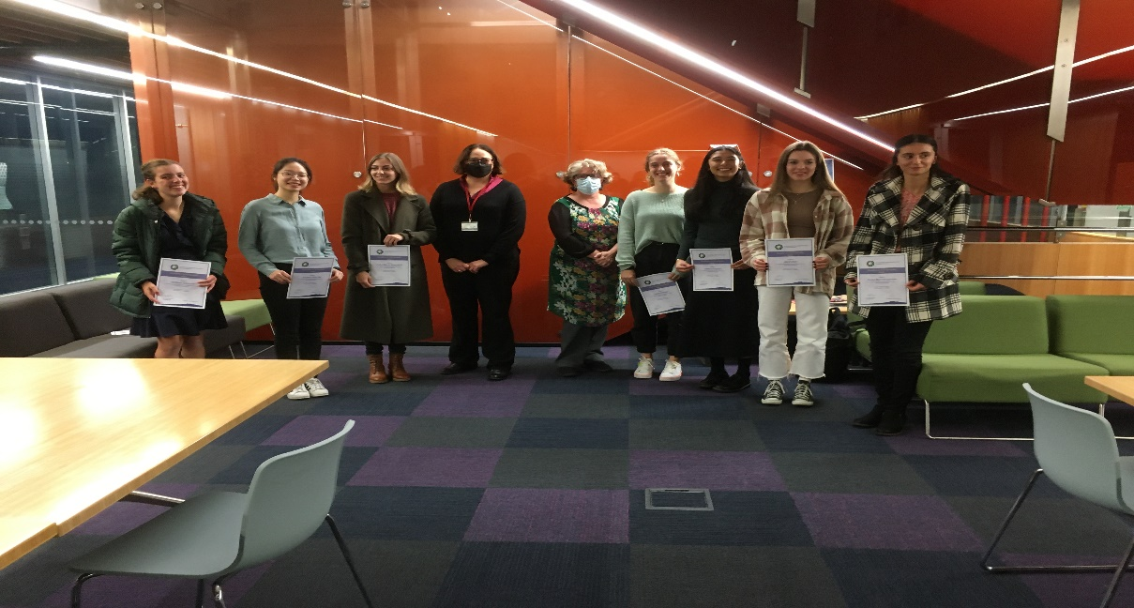

New Zealand Geographical Society Excellence in Geography Awards for achievers of excellence in First Year Geography:
Congratulations to the following students who were awarded an Excellence in Geography award at the Awards Ceremony on Tuesday, 24th May:
Alanna Abrogena, Sasha Barrett-Garnier, Isabel Bloomfield, Summer Edwards, Kyla Fisher, Pippa McCormack Wolf, Natia Mestvirishvili, Janki Patel, Abi Potter, Laura Simcock, Guy Spratt, Alaska Webb, Kiu Hei Chloe Yip

Join the New Zealand Geographical Society (NZGS)?
To join, go to the Membership section on the NZGS website at http://nzgs.co.nz/ Subscriptions for Individuals, Fellows and Schools (including concessionary) can be completed here. You can also join study groups, the Postgraduate Network, and the NZBoGT newsletter under 'Extras'.
To renew your existing membership: also go to the Membership section on the NZGS website at http://nzgs.co.nz/ and enter your username and password. If you have forgotten these, you can request a reset.
New members: select your subscription plan and complete your profile online.

